**Fundamental Computer Programming – Term Project**

ID:1082414

Name:張恆達

* Figure 1:

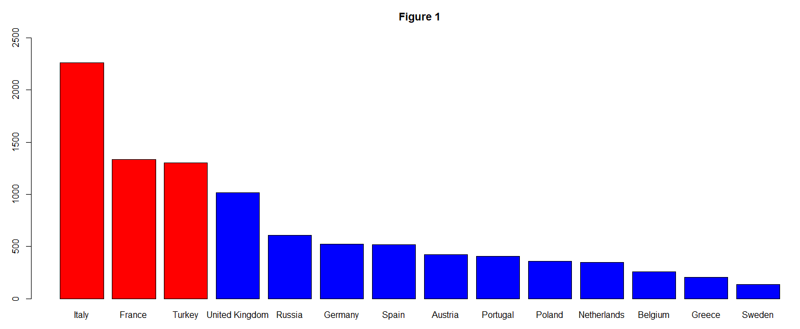

* Question 1:

Italy, France, and Turkey.

* Data Processing 1:

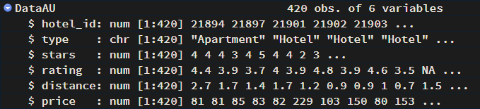

* Figure 2:

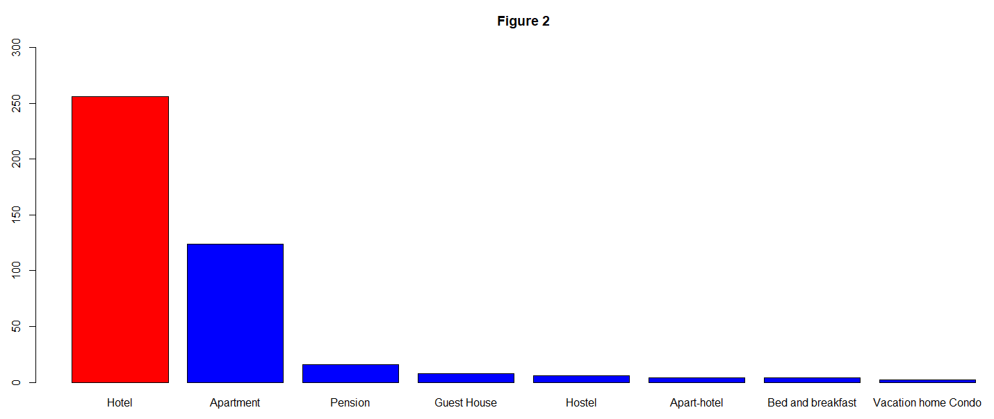

* Figure 3:

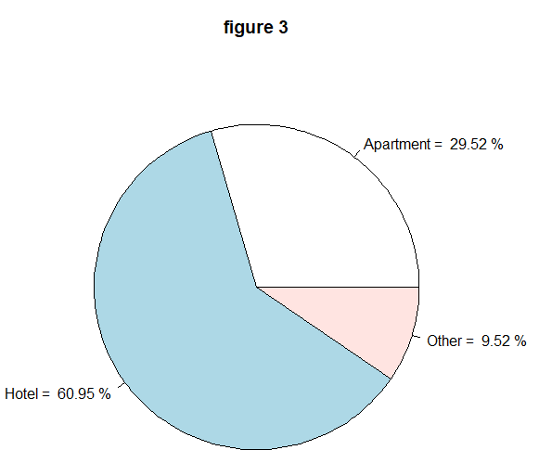

* Figure 4:

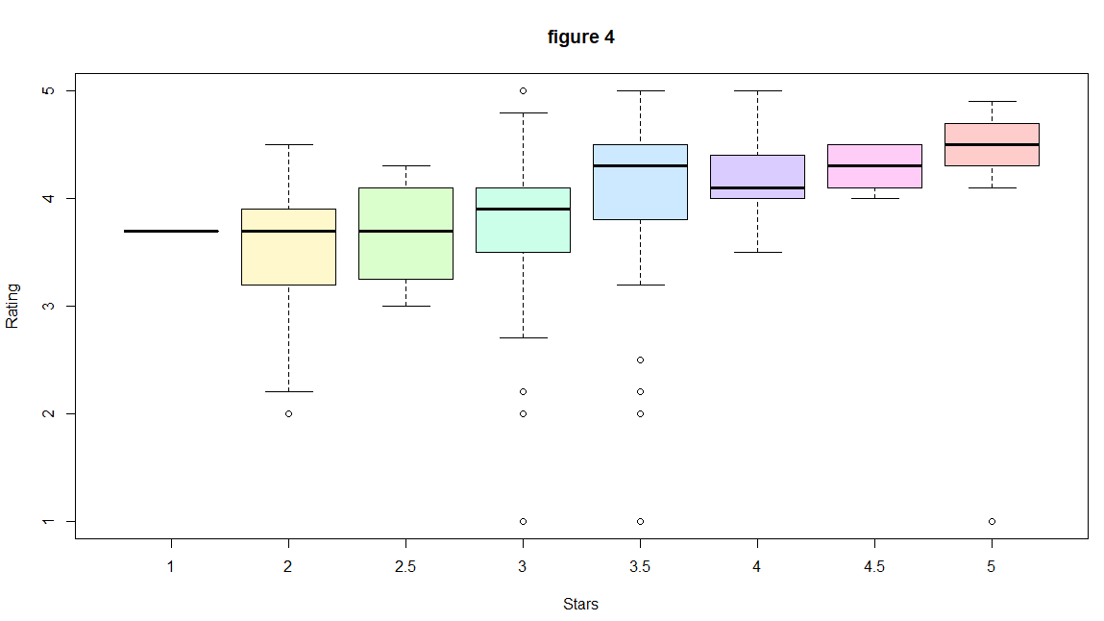

* Question 2:

The more stars a hotel has, the higher quality of service it can provide. And people who will visit expensive hotels usually care more about the quality of service rather than the price, so the number of stars has a positive relationship with the rating.

* Data Processing 2:

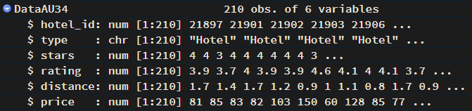

* Figure 5:

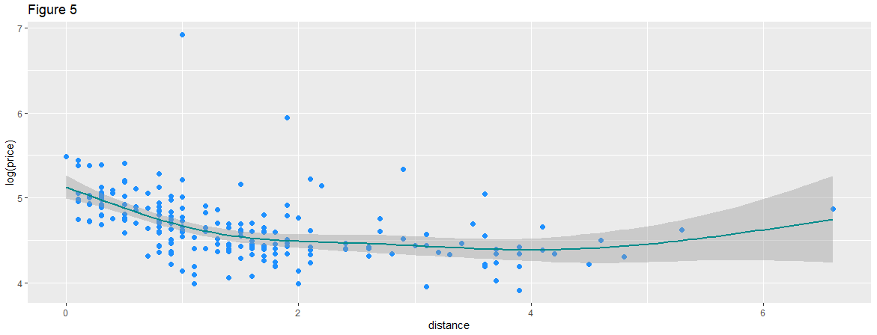

* Question 3:

They are mainly concentrated in the near distance, and the price tends to decrease as the distance increases.

* Data Processing 3:

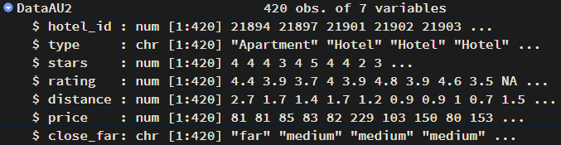

* Data Processing 4:

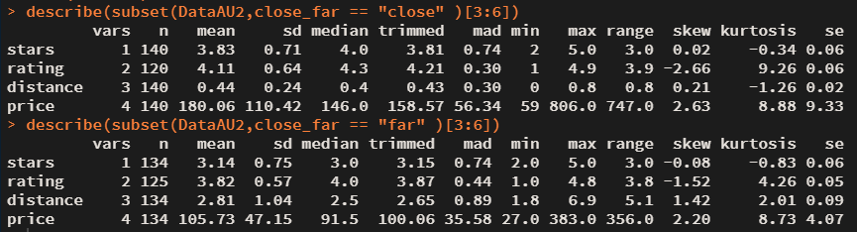

* Question 4:

According to the central tendency (mean and median), the hotels closer to the center have more stars and higher customer ratings.

* Data Processing 5:

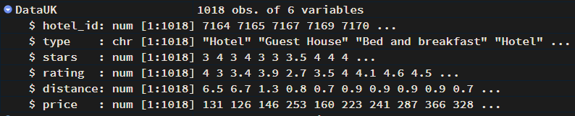

* Figure 6:

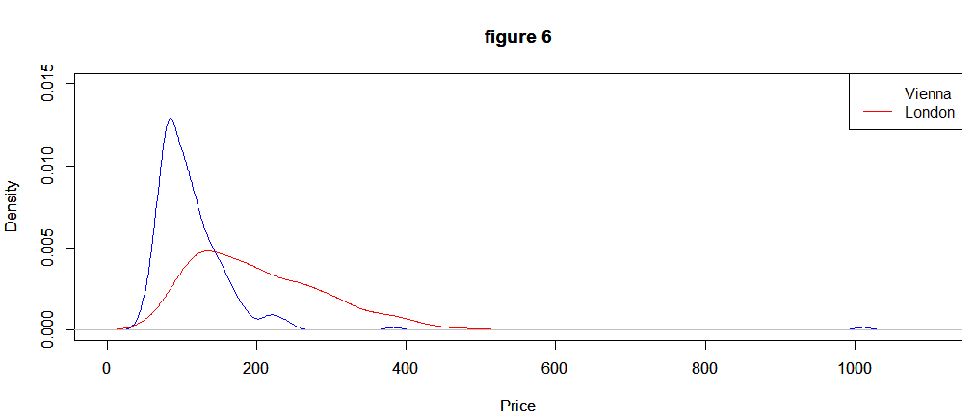

* Question 5:

Compared to London, Vienna seems to be more popular for traveling and sightseeing, so the demand for cheap hotels is higher. The price distribution of hotels in London is more uniform than Vienna.